Document Title | Document Code | Document Type | Issue No | Sop No.
New Feature Request | S-SW-FR | SOP | 01 | 2
Issue Date | Effective Date | Copy No. | Revision No.
01/10/2025 | 01/10/2025 | Master | 0

Purpose
Standardize the intake, evaluation, development, and deployment of new feature requests to ensure alignment with business goals, efficient resource utilization, and stakeholder satisfaction.

Procedure & Flow
Step 1: Request Intake
- Action:
  - Stakeholder submits request via Feature Request Portal or form (business case, expected outcomes, mockups).
  - Required fields: Priority (P0 > P3), impacted subsidiaries.
- Roles:
  - Subsidiary Liaison/Internal Stakeholder: Logs request.
  - Shared Service Coordinator(Technical Team Lead): Assigns tracking ID.
Step 2: Technical Feasibility & Scoping
- Action:
  - Technical Team (Team Lead, Business Analyst, Developers, UI/UX) assesses:
    - Technical complexity
    - Integration points
    - Resource requirements
- Output: High-Level Design (HLD) document.
- Roles:
  - Team Lead: Leads assessment.
  - Software Manager: Approves HLD.
- Timeline: ≤5 business days.
Step 3: Prioritization & Roadmap Alignment
- Action:
  - Review by Feature Review Board (SW Manager, Product Owner, Subsidiary Rep).
  - Prioritize using RICE framework (Reach, Impact, Confidence, Effort).
- Roles:
  - SW Manager: Final prioritization.
Step 4: Agile Development
- Action:
  - Break into user stories; assign to sprints.
  - Bi-weekly stakeholder demos.
- Roles:
  - Dev Team: Implements features.
  - Tester Engineer: Continuous validation.
Step 5: Release & Adoption Tracking
- Action:
  - Deploy via phased rollout (canary release).
  - Monitor adoption via usage analytics.
- Roles:
  - Full Stack Engineer: Manages deployment.
  - BI Team (if any): Tracks adoption metrics
Documents & Records
- Feature Request Form by Shared Service Coordinator
- High-Level Design (HLD) by technical team Lead
- RICE Prioritization Matrix by SW Manager

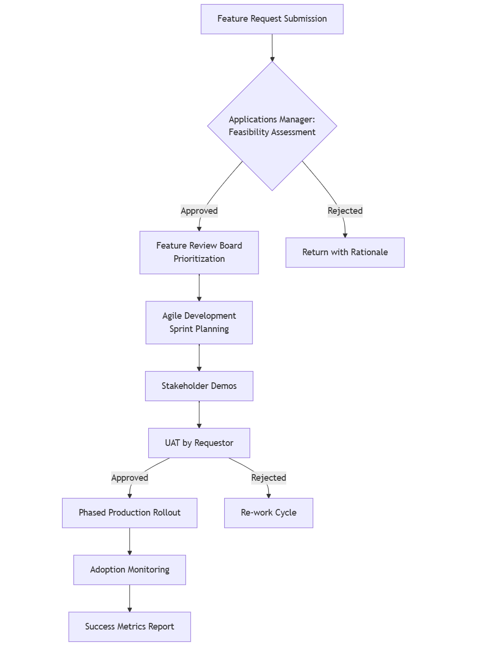
Forms
Form Name | Form Code
SERVICE REQUEST FORM | F-SW-FR/01

Revision History
Rev No | Rev Date | Issue No | Issue Date | Description of Change | Approved By
0 | 01-10-2025 | 01 | 01-10-2025 | Initial Issue

